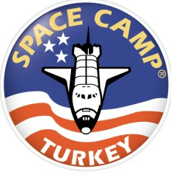
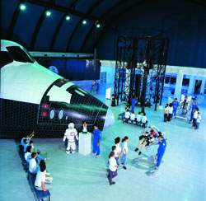 SUMMER JOB AS A
CAMP COUNSELOR
IIN IN

TURKEY 2006

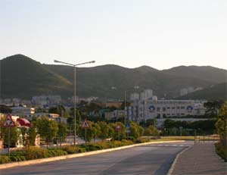
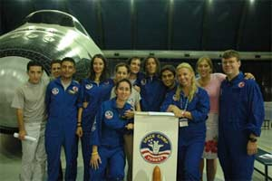
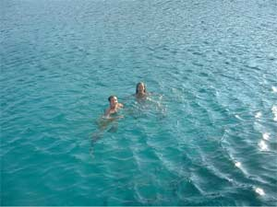
Location: Space Camp Turkey, located in Izmir at the Aegean Free Zone, the leading industrial park in Turkey. The Aegean Free Zone is located 5 minutes from Izmir's international airport and 15 minutes from the city center. It is also close to many historic sites and summer seaside resorts.

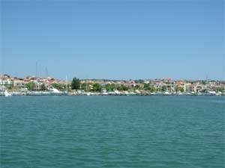
Length of employment:

- June, July and August

Qualifications:
- Enthusiastic, outgoing, friendly personality
- Minimum age: 20
- 1 year of college
- Some experience working with children
- Native speaker of English
- Non-smoking
Compensation:
- Free roundtrip airfare from the U.S. to Izmir
- Free room and board at Space Camp Turkey
- $85-100 spending money per week
Job summary:
- Supervise, motivate and train 9-15 year olds in a fun-filled atmosphere at Space Camp Turkey.
- Each counselor will be assigned to a "team" of 12-13 campers for each 6-day program. Campers will be from Turkey and many other countries in the Middle East and Eastern Europe
- For a detailed job description, please contact Beth Mitchell at Space Camp Turkey, e-mail: beth@spacecampturkey.com

For further information about Space Camp Turkey: www.spacecampturkey.com
